Moon to Mars Planetary Autonomous Construction Technologies (MMPACT)

R. G. Clinton Jr.[1], Jennifer E. Edmunson[2], Michael R. Effinger[3]

*NASA Marshall Space Flight Center, MSFC, AL, 35812, USA*

Michael R. Fiske[4]

*Jacobs Technology Inc., Huntsville, AL, 35806, USA*

Jason Ballard[5], Evan Jensen[6] and Melodie Yashar[7]

*ICON Technology Inc., Austin, Texas, 78745, USA*

Christina Ciardullo,[8] Michael Morris[9], Rebeccah Pailes-Friedman10

*SEArch+ (Space Exploration Architecture LLC) Brooklyn, NY 11221, USA*

1. **Introduction**

NASA’s Artemis Program is a two-phased plan to send American astronauts back to the Moon and to develop the capabilities for long term presence on the lunar surface. In Artemis Phase 1, NASA plans to land the first woman and next man on the Moon. In Phase 2, NASA and its international partners plan to create the infrastructure necessary to enable a sustained long-term presence on the lunar surface. NASA’s Space Technology Mission Directorate (STMD) is supporting the Agency’s exploration initiative by developing key technologies and capabilities. **Figure 1** provides an overview of the investments that STMD is making in the four thrust areas, which are color-coded as are the associated technologies. STMD has also created the Lunar Surface Innovation Initiative (LSII). LSII aims to spur the creation of novel technologies that will be needed for lunar surface exploration and to accelerate the technology readiness of key systems and components focused on enabling a sustainable presence on the lunar surface.

NASA’s Marshall Space Flight Center formulated the Moon-to-Mars Planetary Autonomous Construction Technology (MMPACT) project to address the lunar surface construction thrust area of LSII in partnership with other Government organizations, multiple academia institutions, industry organizations, and the Jet Propulsion Laboratory, Kennedy Space Center, and Langley Research Center. The goal of the MMPACT project is to develop, deliver, and demonstrate on-demand capabilities to protect astronauts and create infrastructure on the lunar surface via construction of landing pads, habitats, shelters, roadways, berms, and blast shields using lunar regolith-based materials.

The ability to excavate, convey, and beneficiate large quantities of lunar regolith for construction materials is key to the successful development of infrastructure at scale. An early projection of lunar regolith materials needed for a 100 feet diameter landing pad was estimated at several hundred tons. Transportation of that quantity of materials, or even binders for the regolith, from Earth would be extremely costly and impractical as Artemis proceeds into Phase 2 with multiple infrastructure elements required on the surface such as the aforementioned landing pads (multiple), roadways, habitats, shelters, storage facilities, etc. While there are multiple constituent materials in lunar regolith that could serve as binder materials for raw regolith such as calcium, sulfur, aluminum, magnesium, and others, the ability to produce these materials in sufficient quantities from the raw regolith will require time. For these reasons, MMPACT is also evaluating directed energy methods, such as microwave sintering, laser sintering, and high temperature methods for melting and sintering regolith.

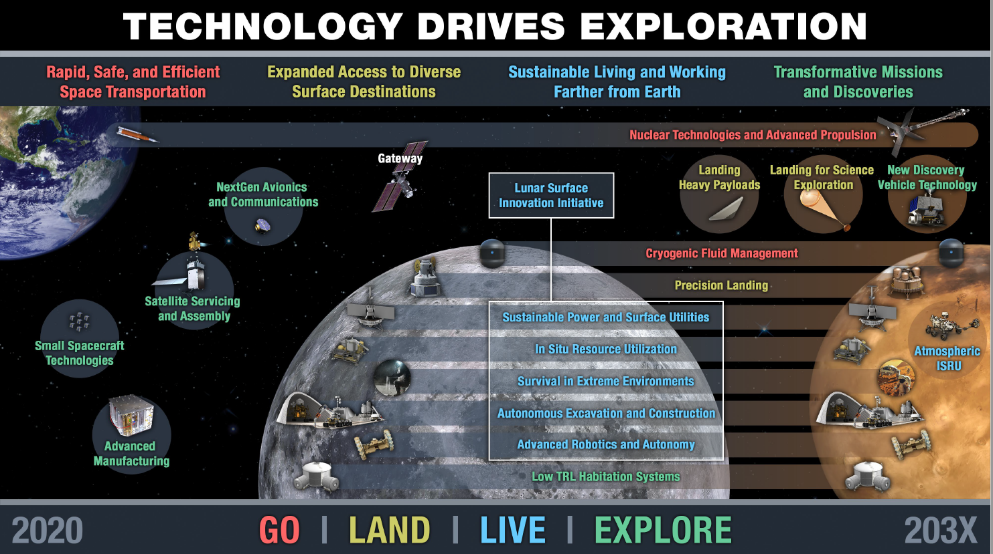**Figure 1. Space Technology Mission Directorate’s technology thrust areas supporting exploration and the Lunar Surface Innovation Initiative focal areas.**

1. **Background**
2. **IN SITU FABRICATION AND REPAIR (ISFAR)**

NASA MSFC has a long history in additive construction technology development. In 2004, NASA’s Office of Biological and Physical Research (OBPR) restructured its portfolio to increase focus on support for exploration. Between 2004 and 2007, the Exploration Science and Technology Division at MSFC executed the In-Situ Fabrication & Repair (ISFAR) Program Element that focused on identification and development of technologies for infrastructure development on the Moon and Mars, as well as characterization and development of various planetary simulants. A synopsis of the key elements of ISFAR is provided in **Figure 2**. The vision and technology development framework created in 2004 were foundational, and not only formed the basis of NASA’s In Space Manufacturing initiative today, but also included the development of additive construction capability for habitat structures using lunar regolith simulant-based concrete.1 More than 25 different research projects were funded under the Habitat/Structures effort. These included: (1)Materials - identification and usage of raw materials, regolith, rock, and lava tubes; (2) Habitat Structures - additive construction, particularly using sulfur concrete (sulfur binder, regolith aggregate) as a construction material, inflatable domes, use of regolith bags and foldable/deployable structures; (3) Processing Technologies - glass melting for structural members, fiber, and rebar. Contour Crafting was identified as a prime candidate for an autonomous construction technology on the lunar surface. MSFC worked with Dr. Behrokh Khoshnevis at the University of Southern California on his early Contour Crafting technology. The viability of additive construction for planetary habitats was demonstrated6 (**Figure 3)** and early construction concepts were developed7 as shown in **Figure 4**. Unfortunately, these Program Elements were short-lived, as Agency priorities changed in 2005 and these efforts were phased down, but not before MSFC gained valuable experience in “printing” with lunar regolith simulant-based concrete2.

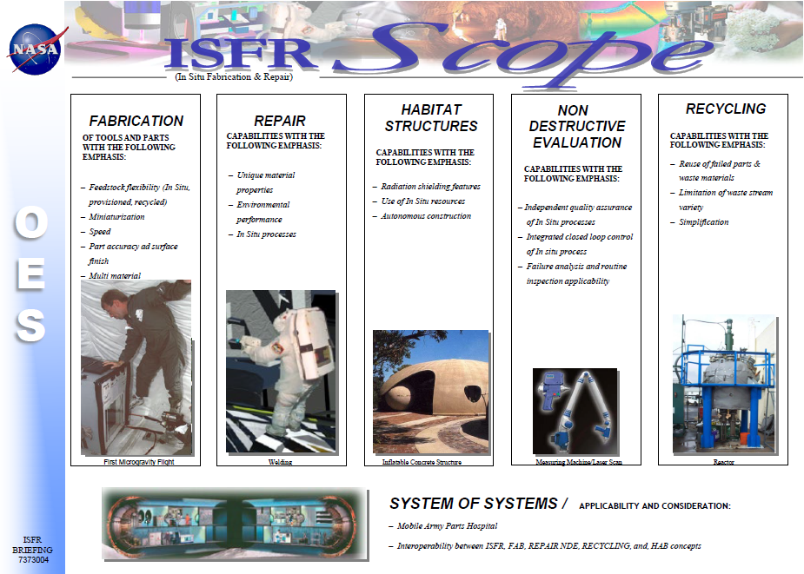

**Figure 2. Technology development focal areas of the In Situ Fabrication and Repair (ISFAR) Program Element for NASA Human Systems Research and Technology Office, 2004.**

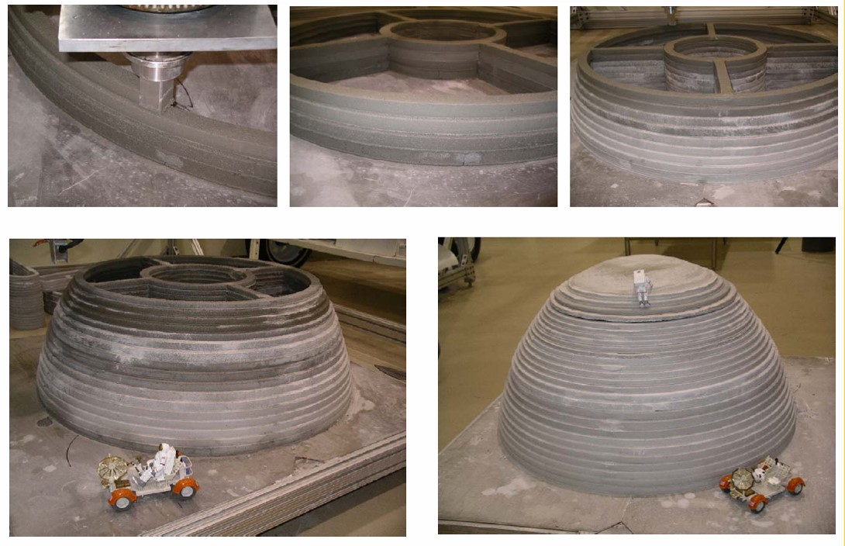

**Figure 3. Early Lunar Habitat Design Concept Built at MSFC in 2005**

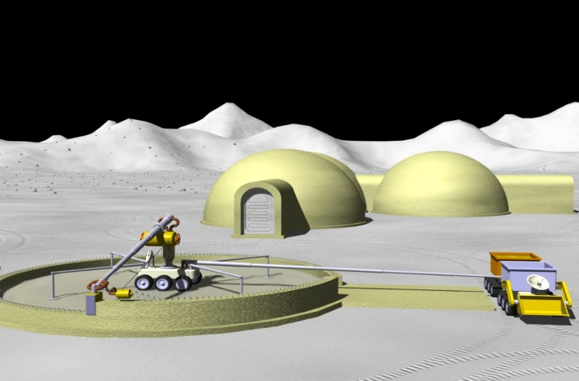

**Figure 4. 2006 Lunar Habitat Design Concept Based on Additive Construction of Sulfur Concrete**

1. **ACES / ACME**

In 2014, Professor Khoshnevis contacted MSFC about the possibility of working with the U. S. Army Corps of Engineers Construction Engineering Research Laboratory – Engineer Research and Development Center (CERL-ERDC), on additive construction technology development. The project, entitled Automated Construction for Expeditionary Structures (ACES) for CERL-ERDC and Additive Construction with Mobile Emplacement (ACME) for NASA was a joint venture between NASA’s Space Technology Mission Directorate Game Changing Development Program and the US Army Corps of Engineers. The projects shared a common vision. The CERL-ERDC version of the vision was, “capability to print custom designed expeditionary structures on-demand, in the field, using locally available materials.” With only minor modification, the NASA version of the vision is “capability to print custom designed exploration structures on-demand, on extraterrestrial surfaces, using locally available materials (or regolith)”3. The CERL-ERDC interests in this technology were to reduce the logistics requirements for forward operating bases and reduce exposure and risk to personnel by reducing the number of construction personnel and the time required to construct the desired structures. NASA’s interests are in the development of a system that is capable of constructing multiple structures, such as habitats, landing pads, berms, roadways, etc., autonomously by using regolith as the basic building material in combination with binders tailored to be created from the locally available materials on the Moon or Mars to support human deep space exploration1. Team members and their primary responsibilities wereCERL-ERDC, (cementitious materials research, concrete constituency, properties, and flow process parameters and control relationships, analysis and design of structures, and full scale additive construction demonstration); Kennedy Space Center (KSC) (excavation and handling of regolith materials, dry goods storage and delivery system, and integration of the dry good and liquid delivery systems); Contour Crafting Inc. (print nozzle development and fabrication); and MSFC (liquids delivery system, concrete mixing and delivery system development and verification, binder development for Mars regolith simulant-based concrete, mobility system design and construction). Additional information on project development activities can be found in references 4 and 5. The MSFC designed and fabricated 54’ x 32’ x 21’ tall gantry-style additive construction printer was delivered by MSFC to CERL-ERDC in 2018 to enable military infrastructure development.8,9 The gantry can be seen in the middle of an aerial photograph shown in **Figure 5**, with the dry materials storage and delivery system and liquids storage and delivery system developed by KSC in the upper right in front of the large tent structure.

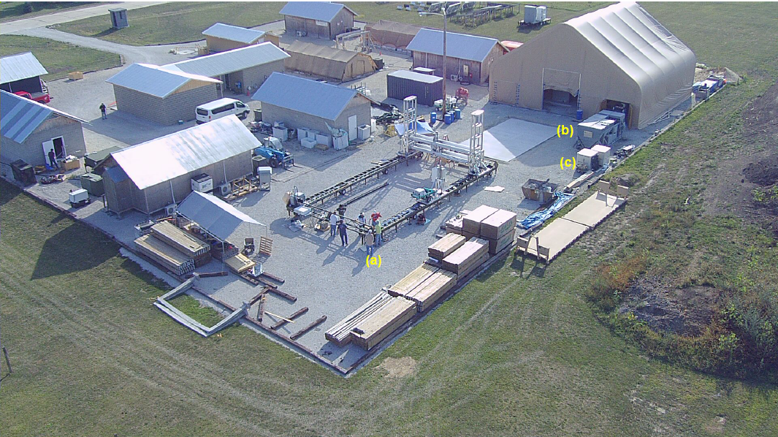

**Figure 5. Aerial Photo of ACES-3 system at the CERL-ERDC facility showing (a) gantry print and mobility system; (b) dry materials storage and delivery system; and (c) liquids storage and delivery system.**

1. **MMPACT Formulation**

After the formation of LSII in mid-2019, MSFC began to formulate plans to support the construction element of the Excavation and Construction thrust area. An initial step was to enlist Yet2 to perform surveys of the state of the art and emerging materials for lunar construction and also for state of the art and emerging construction technologies suitable for use in the lunar environment. These surveys were instrumental, along with the prior MSFC experience base, in selecting the candidate material systems and associated processing technologies. In addition, NASA’s 3D- Printed Mars Habitat Centennial Challenge had recently completed. NASA’s Centennial Challenge for a 3D-Printed Habitat (2015-2019) sought to identify state-of-the-art capabilities for large-scale additive manufacturing within industry, in addition to advancing the viability of Building Information Modeling (BIM) workflows for construction operations in space. The competition was subdivided into multiple Phases of Virtual Design (schematic architectural design concepts), as well as Construction submission levels (3D-printing demonstrations for a compression cylinder, foundation, beam member, etc.). Two finalists in the Centennial Challenge, Space Exploration Architecture (SEArch+), winners of two phases of the design element of the Habitat Challenge, and ICON, a finalist in the construction element of the Habitat Challenge were in discussions with MSFC about opportunities to continue the development of additive construction technologies. These early discussions resulted in a framework for the creation of a proposal that would be subsequently submitted to the NASA Space Technology Mission Directorate call for proposals addressing the LSII thrust areas.

## SEArch+ / MSFC Venn Diagrams

The promise of the Centennial Challenge was to advance technology development for space that simultaneously (meets some) (intersects with) the global challenges of sustainable development on Earth. The natural synergies between architecture, engineering, and construction (AEC) and the aerospace industry: from smart homes to net zero applications, from the design of small efficient spaces (dense urban housing & development) to sustainable practices employing local material, water, and energy recycling. Typically, the technology transfer from the aerospace sector occurs after it has been researched and developed. Rather than wait for later exchanges and spin-off applications to facilitate the transfer of embedded knowledge from the AEC and Aerospace industry, SEArch+ worked with NASA to identify applications which can be developed and tested simultaneously in order to pool resources previously divided between these sectors.

Considering habitats as holistic endeavors between technology goals, human habitation needs, and systems requirements, SEArch+ initiated a series of “Venn diagrams” to identify overlapping research interests between AEC goals and space habitats including: Construction Technology Material Innovation, Sustainable Operations, and Human Factors. Among many areas of overlap, in the area of construction means and methods while there were clear differences in terms of the requirements of the operational environment, while overlaps were identified in terms of needs for autonomous operation, reduced build time, and mobility systems development. In terms of environmentally induced building performance, while Earth construction is held to a number of well-established standards (ASTM, IBC, ASCE, etc.) and new standards would need to be developed for space, there were similar requirements in terms of meeting a certain level of building envelope tightness, thermal performance, and factors of safety. The Venn diagrams gave way to a series of comparative requirements to examine the potential opportunities as well as the limitations to parallel tracking of a building research project between earth and space sectors.

1. **ICON / Venn**

During this time, ICON was also developing a Dual-Use Strategic Interest Small Business Innovation Research proposal with the Texas Air National Guard (TANG). MSFC was offered an opportunity by the TANG to join as a partner in this proposal. Subsequently, the Air Force Civil Engineering Center at Tyndall Air Force Base and the Defense Innovation Unit also came on board as partners. Large-scale additive manufacturing introduces shared technology development goals on Earth for the residential construction market, as well as for the Department of Defense (DoD), and in space for the purposes of autonomous in-situ resource utilization (ISRU) surface construction on the Moon and Mars. Additive construction is uniquely suited for both earth & space applications, given that it enables construction of a variety of structures on-demand in variable settings using local materials. The same Venn diagram process previously described was utilized by both ICON for commercial structures and the DOD organizations for military applications. In early 2020, ICON led the definition of functional requirements for construction-scale additive manufacturing for terrestrial residential construction, for in-space construction on the Moon and Mars, and for military construction applications desired by the DoD organizations. The requirements revealed shared technology development goals across the three sectors, such as reliability and repairability within harsh and/or unpredictable environments.

The requirements definition gave way to suggested areas of mutual collaboration among ICON, NASA, and the DoD, including: development of long-range communication, monitoring and control systems, autonomous mobility within variable sites, dust mitigation strategies, projectile shielding strategies (against micrometeorites, bullets, shrapnel, blasts, etc.), advanced software controls, building information modeling (BIM) systems, remote teleoperations, off-foundation printing and/or autonomous foundation delivery, design for field repair, and advanced autonomy capabilities such for site preparation. Areas of collaboration identified between ICON and NASA alone included: transportation and payload requirements, hardware system architecture and requirements, Lunar power requirements, materials science for regolith print medium, regolith excavation, materials handling, and feedstock delivery systems. These common key functional capabilities formed the framework of ICON’s successful SBIR proposal and the foundation of the MMPACT project.

1. **Architectural Design Concepts by ICON**

In 2020, ICON’s proposal was selected for an SBIR award. An initial step taken by ICON was to employ SEArch+ and the Bjarke Ingels Group (BIG) to develop design schematics for mission-critical surface construction elements for a permanent lunar base. The design process was informed by discussions with key ICON engineers and NASA collaborators. The exchange not only ensured the constructability of designs according to known hardware constraints and material processing limitations, but also enabled the architectural process to influence and shape Project Olympus hardware requirements as they were being defined. Project Olympus is ICON’s multi-year initiative to develop an autonomous, large-scale construction system capable of manufacturing horizontal and vertical construction typologies on the Moon and eventually Mars. ICON’s construction system is planned to first demonstrate capabilities to manufacture critical horizontal structures such as roads and landing pads, followed by demonstrations of critical vertical structures including unpressurized shelters and habitats. Within this study, SEArch+ developed landing pad concepts and BIG developed a foundational habitat design, as well as the master plan for a permanent Lunar base.

1. SEArch+ Landing Pads

The design and construction of lunar landing and launch pads ranks as a high-priority element of strategic infrastructure to be constructed on the surface of the Moon. To develop civil infrastructure on the Moon and eventually Mars, repeated visits to the same location will be necessary. Landing pads on the Moon would prevent regolith dust from sandblasting other infrastructure at 3 km/s, which would spread over the surface of the Moon and even enter lunar orbit. A landing pad provides a stable zone for a lander’s touchdown and would deflect exhaust plumes without excavating a hole under the lander, and the construction of landing pads from in situ resources will mitigate risks posed by frequent and repeated landings to locations close to a lunar outpost. Lunar landing pads would benefit from being close to an initial lunar outpost’s critical infrastructural elements to allow for safe and efficient off-loading of cargo, goods, and resources. While logistical proximity to infrastructural elements would increase operational efficiency, standoff distances ensuring habitable and occupiable structures’ safety remain a critical constraint in site planning. Standoff distances need to be great enough to protect outpost structures from damage against rocket plumes and also from the acceleration of dust particles during landing and launch.

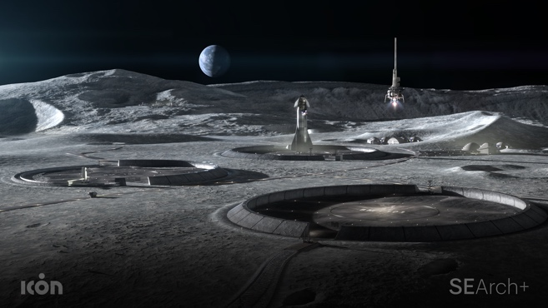 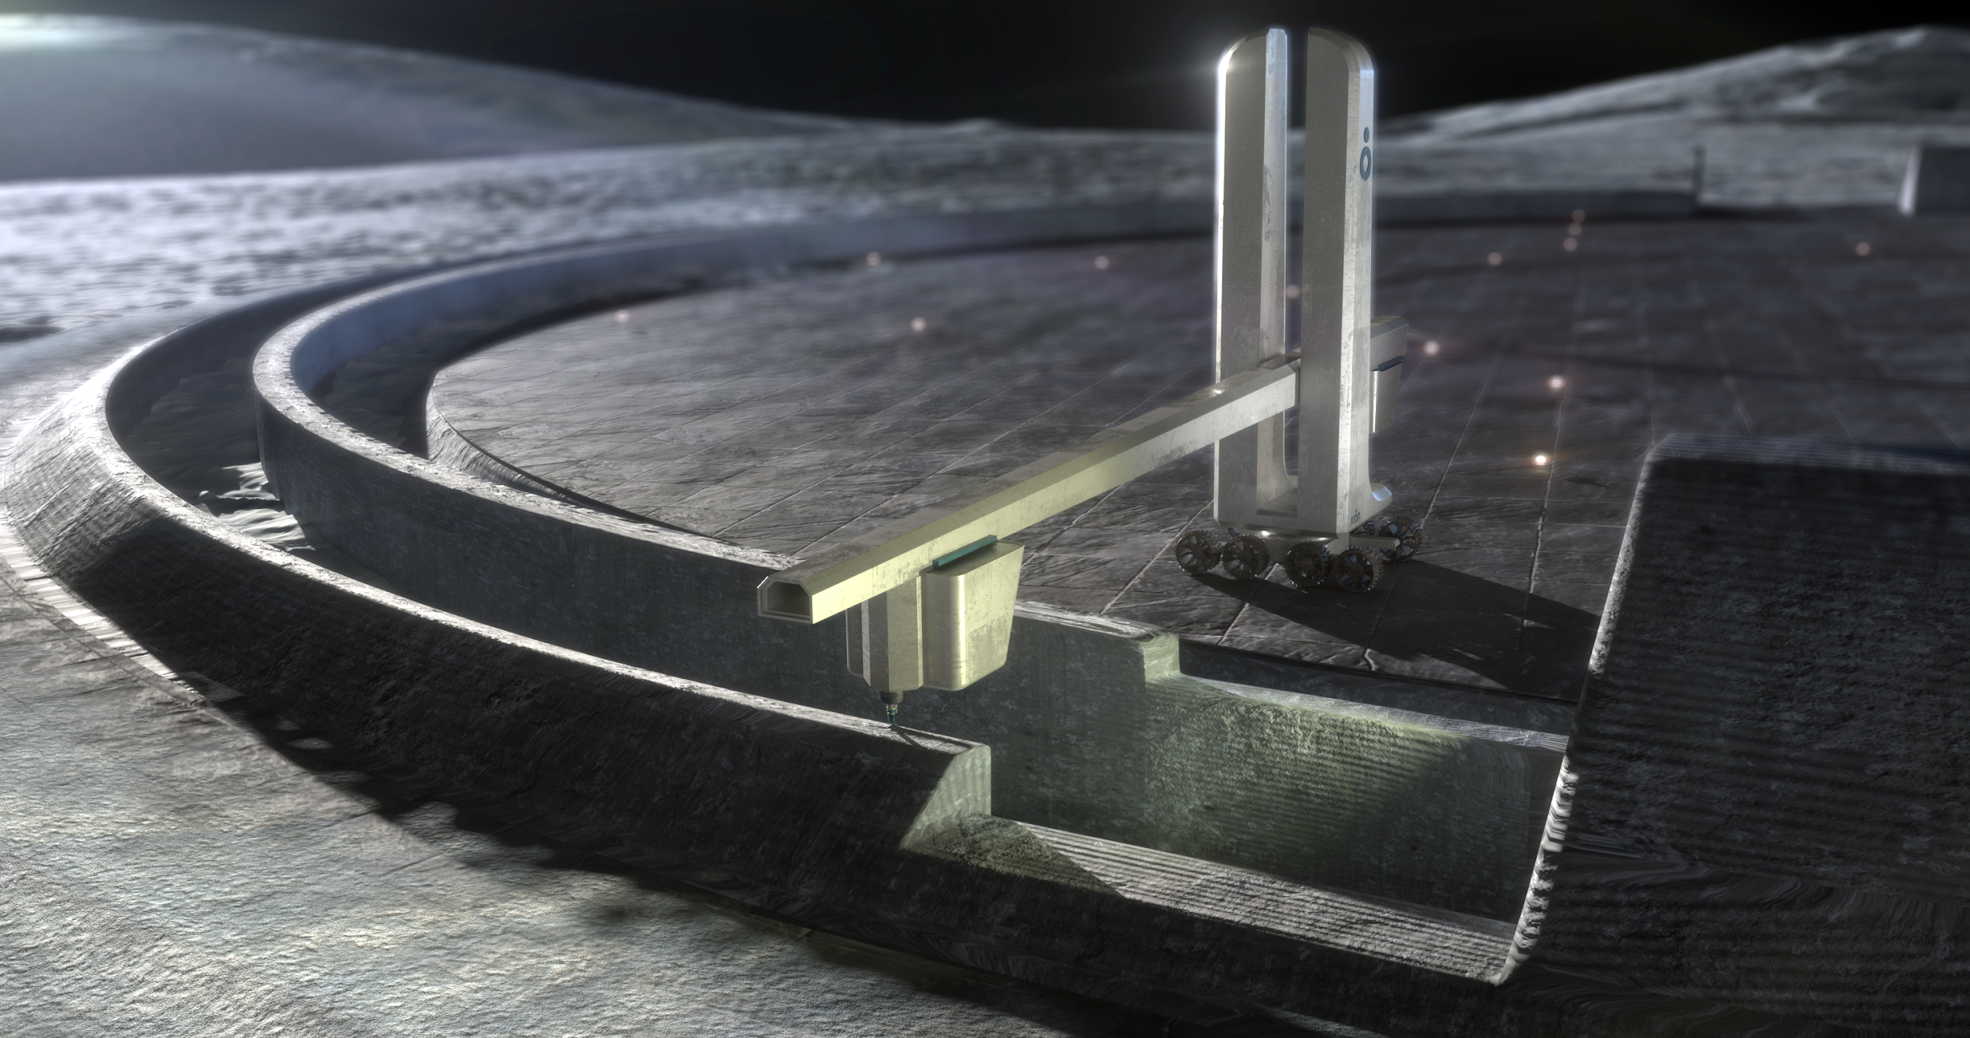

**Figure 6 (Left) Schematic representation of landing pad designs**

**Figure 7 (Right) Concept for the Olympus construction system**

High-velocity dust impacts are a significant design driver for landing pads. As dust particles become airborne, they can accelerate to supersonic speeds and travel beyond the lunar surface and enter into orbit. We have evidence demonstrating that larger particles, traveling at supersonic speeds, eject at a lower angle of 3 degrees, and slower, smaller particles eject at a higher angle closer to 17 degrees9. Smaller particles are more subject to intra-particle collisions, slowing down the travel speed and giving rise to more complex trajectories. Current research indicates that the majority of ejecta can be contained with a blast wall at the height of 17 degrees.10 The blast wall in the design study included an angled dust barrier with a height determined by the 17 degree angle requirement,and a dust trench that would collect most of the supersonic ejecta for later removal.

The landing pad study expands on prior research differentiating the touchdown or center zone of the landing pad from the immediate area surrounding it, described as a secondary zone.11 Four main components for a landing pad are introduced, including multi-material concentric rings for the central landing surface, a blast wall, a support berm, and a dust trench. Within this study, multiple construction options were considered, including: a continuous sintering method, paving options which include a solid paving surface, the creation of interlocking paver elements, and a layer of 3D-printed gravel aggregate. Further study of how solid paving, 3D-printed gravel, and interlocking pavers behave is needed before a final recommendation is made.

1. BIG Foundational Habitat

The proposed foundational habitat is a single-story torus-based structure supporting a crew of four, based on the upcoming Artemis missions.12 Among the various mission drivers typically used to determine habitat sizing and habitable functions, crew size was a known parameter within the project. The design team created functional work and living spaces that would not only be adequate for future long-duration missions of six months or longer, but sought to introduce architectural and interior design elements that promote crew cohesion, performance, and overall health and well-being. Among these strategies are circadian lighting solutions to adapt to crew’s activities over the course of a single Earth-day or 24-hour light/dark cycle. Circulation for the habitat follows the linear path of the torus structure. Areas for crew living and leisure are separated from science and research activities by airlocks to ensure the safety of the crew. Windows are located to ensure constant visibility of Earth.

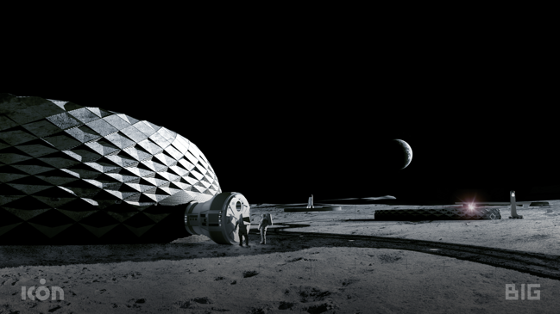 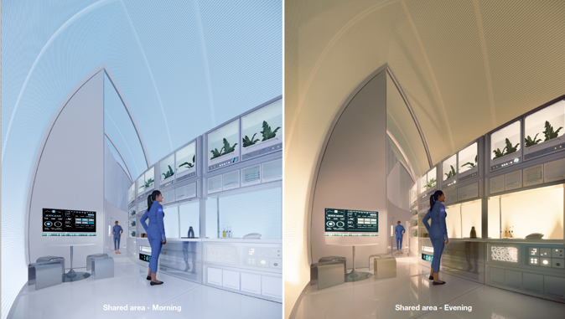

**Figure 8 (Left) Exterior of habitat design**

**Figure 9 (Right) Circadian lighting within interior of habitat**

Throughout the habitat’s lifecycle, the structure will need to prove resilient to cyclic and fatigue loading, long duration seismic events, asymmetrical thermal loading and internal pressurization. The habitat’s structure essentializes the use of 3D-printing for the torus’ interior ribbed lattice and incorporates loose regolith infill for additional radiation shielding. This approach makes reasonable assumptions that excavation and material handling technologies will support additive manufacturing capabilities on the Lunar surface and may be less time and energy intensive as compared with laser, furnace, or microwave-based construction methods. Several technology development challenges have been considered as constraints driving the final geometry of the habitat. First, printing tangent overhang angles less than 20° from a previously printed layer without structural support is a present limitation of the state-of-the-art, and thus was assumed as a constraint within the design process. Second, it is yet unknown whether regolith construction alone may create a hermetic seal structurally sound enough to maintain internal pressurization on the lunar surface. Regolith is materially porous and present research has yet to indicate that it may support the creation of an airtight seal. The design proposes deploying a fabric or material liner to the inside of the regolith shell and applying a spray-on polymer-based material to seal the interior of the structure.

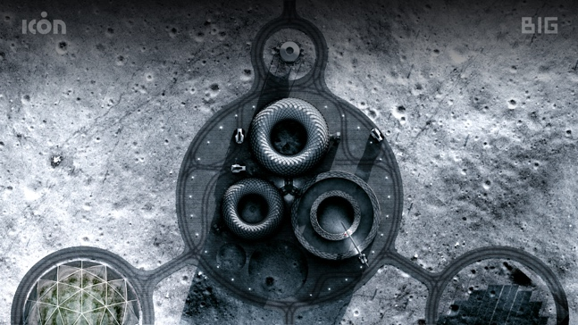 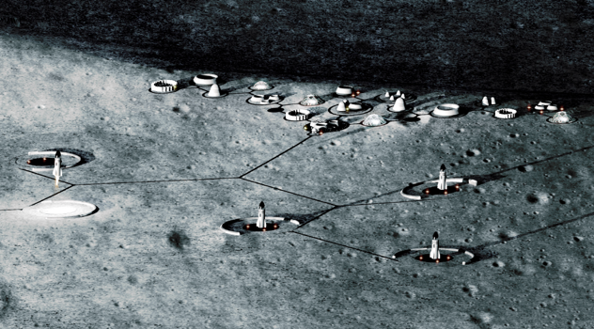

**Figure 10 (Left) Clustering of foundational habitat & Lunar base infrastructure**

**Figure 11 (Right) Depiction of phased expansion within master plan**

The foundational habitat is envisioned to scale and expands into a master plan over the course of a phased development timeline. Principles informing requirements for the design and planning of the lunar base include safety, resiliency, efficiency, redundancy, and expandability.13 Essential infrastructure elements within the master plan include: power sources such as a solar array, landing and launch facilities located at a sufficient distance away from habitable structures, storage, maintenance and repair facilities, as well as ISRU processing facilities. The phased development timeline projects that roads, unpressurized radiation shelters will be the first elements to be constructed. Landing pads would be the next elements to be constructed, followed by the establishment of power and energy resources as well as ISRU production facilities, until finally the foundational pressurized habitat is constructed with additional clusters following soon after.

1. **Element Summaries**

The MMPACT Project is focused on the development, delivery, and demonstration of on-demand capabilities to protect astronauts and create infrastructure on the lunar surface using lunar regolith-based materials. To accomplish these goals, MMPACT is divided into three interrelated elements: Construction Feedstock Materials Development, Olympus – Autonomous Construction System, and the Microwave Structure Construction Capability (MSCC). These elements are described below.

## Materials

The MMPACT Materials element is a supporting element to the Olympus and MSCC elements. The Materials element provides a common platform for regolith simulant, Olympus, and MSCC evaluation and test. Some research in ISRU-based construction falls under the Materials element, including the production of cementitious and metal alloy materials. This research is necessary to help establish the capability of producing construction materials in-situ. Activities of the Materials element include establishment of test parameters, procurement of simulant, and formulation of partnerships with organizations outside of NASA to assist in NASA’s surface construction materials work.

1. **Olympus**

The Olympus element of the MMPACT project is focused on development and test of planetary additive construction hardware. Early efforts are focused on the initial surface construction technology demonstration mission (DM-1), slated for December 2026, described in the following section. A number of deposition techniques and materials are being evaluated as part of this element. ISRU-based cementitious materials (with and without water as a binder), sintering techniques, and others are all being evaluated. A materials/deposition technology down-select for the DM-1 mission is slated for mid-2022.

NASA is working with MMPACT partner ICON, of Austin, TX, on the development of the hardware to support these activities. ICON brings a wealth of experience to the table, including real-time measurement of concrete, development of mixing and pumping protocols and hardware, and has dealt with issues like hose management, which become problematic at large scale. In addition, they have a strong background in controls system development, remote operations, and design of structures for seismically active areas as well.

One of ICON’s first MMPACT activities resulted in the construction and subsequent hot fire test of a 20’ diameter 3D-printed landing pad. Shown in Figure X, the LunarPAD was designed and analyzed by a group of college students that were mentored by MMPACT personnel. The pad was constructed in October 2020 and tested in March 2021.15

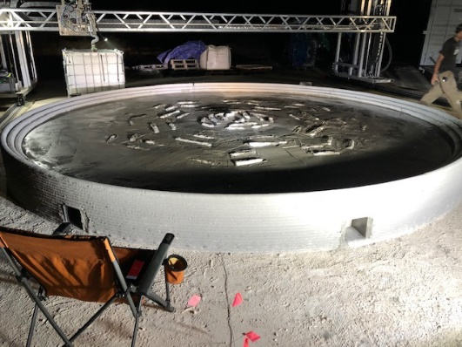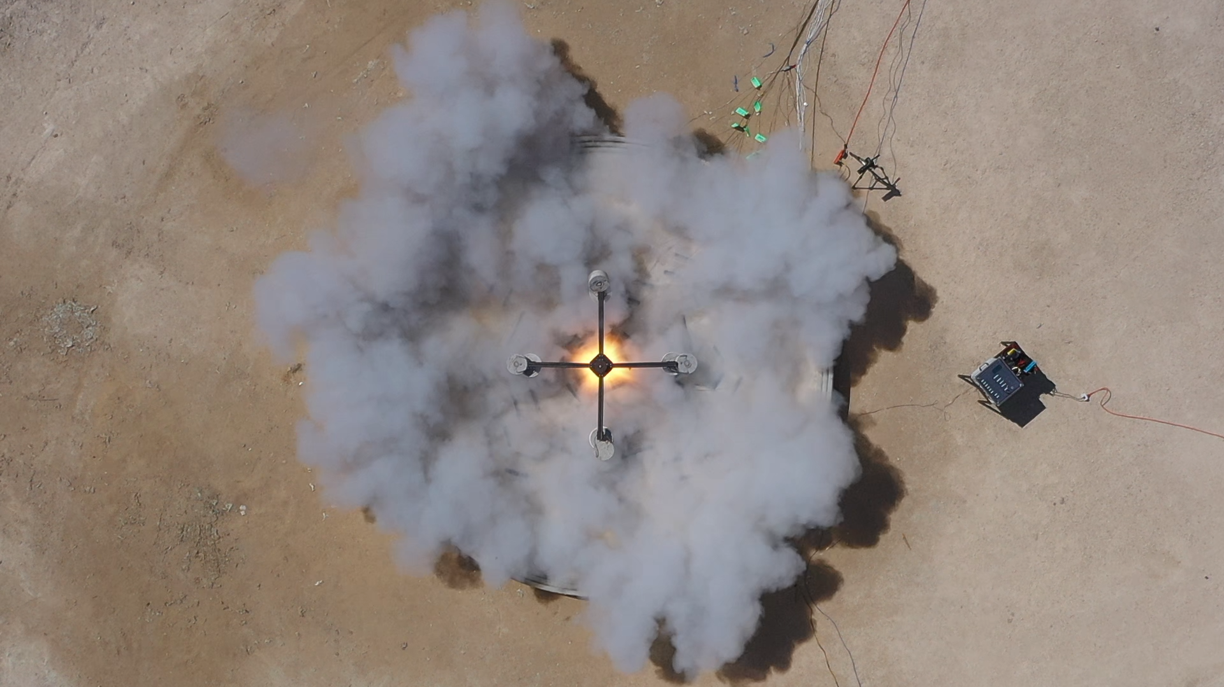

**Figure 12. Lunar Pad Subscale 3D Printed Landing Pad (left – after completion, right – during hot fire test)**

1. **MSCC**

MSCC traces its origin within MSFC back to the mid-2000s during Shuttle Return to Flight. Internal development was done on a microwave heater to cure and sinter the Reinforced On-orbit Carbon-Carbon Crack Repair (ROCR) using Non-Oxide Adhesive Experimental (NOAX) repair material.16 Former ROCR team members were located and additional industry, academia, and government personnel were added to develop microwaves systems and protocols for creating horizontal and vertical infrastructure on the Moon. Microwave energy is being pursued for regolith consolidation by MMPACT since it is the only heating method to volumetrically heat the regolith. All other methods rely on thermal conduction through the very low conductivity regolith to sinter, resulting in a less efficient process. However, significant challenges exist to scale up microwave processing to where densifies infrastructure in a lunar environment.

Since there isn’t enough lunar regolith to develop the processes and protocols, simulants are being used. The simulants are processed from terrestrial feedstocks which contain non-lunar materials in them. Therefore, a five-month effort was conducted to establish a heat treat method to remove these non-lunar materials. Tests were conducted using thermal gravimetric analysis, mass spectrometry, heating in vacuum and conducting mass spectrometry, dielectric and differential thermal analysis, Raman, Brunauer, Emmett and Teller (BET), particle size analysis, morphological analysis, carbon and sulfur chemical content determination and microscopy.17,18 The process has been scaled-up to 6 kg batch size and undergoing evaluation. A 36 kg batch size is the target for JSC-1A and other limited availability simulants. These calcining protocols will be standard for NASA and beyond.

Using baked out simulants, microwave sintering is conducted at Jet Propulsion Laboratory (JPL), Alfred University and MSFC in thermal vacuum. JPL is conducting small scale sintering experiments to develop protocol that will feed into large scale sintering in a similar manner that would be done on the Moon.19,20  The large-scale microwave sintering is being done at MSFC and Alfred University in Thermal Vacuum Chambers (TVACs) with applicators tested in a manner that would be used in a similar way on the Moon for the first time. The goal is to use both magnetron and solid state to sinter strips or paving mats and then join them horizontally. Vertical layers will also be fabricated. Once these specimens are obtained, property specimens will be extracted and tested mechanically, thermally, and with a torch. The largest TVAC sample so far is shown in **Figure 13.** The sintering process using different applicators is being modeled. In order to avoid having a precise simulant, several minerals are being fabricated and tested to establish models that bound the possible varied compositions on the Moon.21 These sintering protocols and resulting properties developed and microwave coupling models will feed into conceptual system designs, conops, and site preparation, microwave sintering, and verification and validation requirements development.22

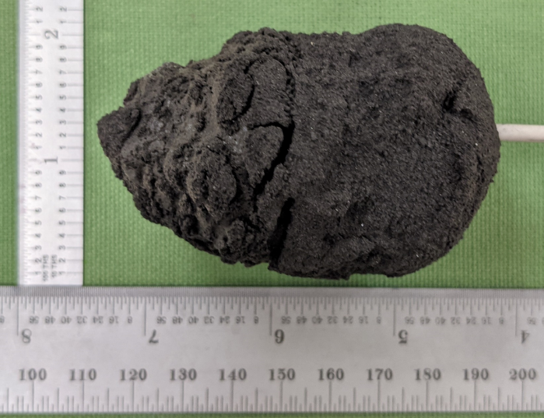

Figure 3. Largest TVAC microwave sintered sample to date.23

1. **Plans for Construction Demonstration Mission – 1 (DM-1) on the Lunar Surface**

The current Space Technology Mission Directorate planning indicates an initial mission in late 2026 for surface construction technology demonstration on the lunar surface. The MMPACT project is focused on development and selection of construction technologies that would be demonstrated on this mission. The overall goal of DM-1 is proof of concept for the initial selected construction technology in the lunar environment. The objectives of the DM-1 mission are as follows:

* Demonstrate downselected construction technique utilizing ISRU materials at small scale from the lander base (produce horizontal and vertical subscale “proof of concept” structural elements)
* Demonstrate remote/autonomous operations
* Demonstrate early instrumentation for system health monitoring and process monitoring/control for material deposition
* Validate (or refute) that Earth-based development and testing are sufficient analogs for lunar operations
* Generate information to anchor analytical models

The DM-1 mission will be based on a Commercial Lunar Payload Service (CLPS) lander that will target the South Pole region of the lunar surface. An initial design concept for DM-1 is shown in **Figure 14.** The planned outcomes from this demonstration are the achievement of Technology Readiness Level 6 for autonomous/remotely operated ISRU consolidation into densified, subscale horizontal and vertical structural elements and Technology Readiness Level 9 for limited hardware and instrumentation that will feed forward and be used on later missions.

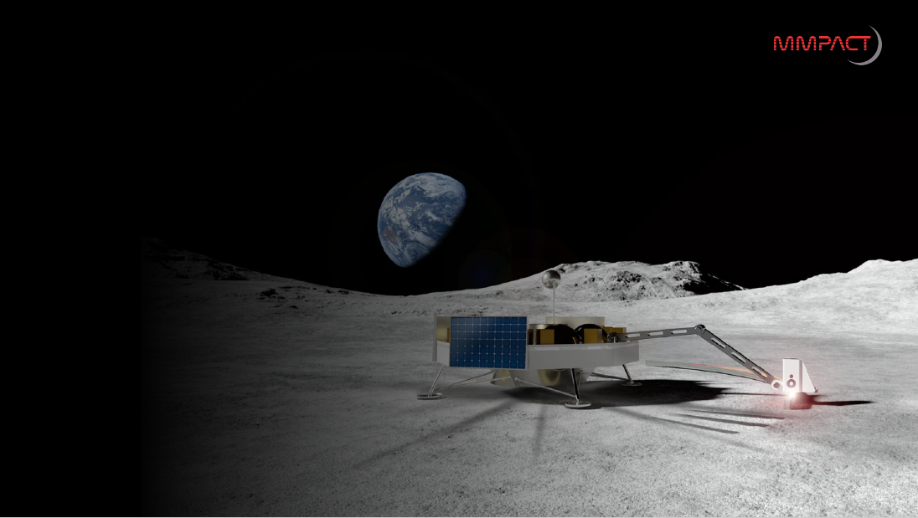

**Figure 14. Concept of lunar surface construction technology demonstration mission one (DM-1) mission operating from the deck of a Commercial Lunar Payload Service lander.**

1. **Notional Lunar Construction Roadmap**

Looking forward for the continued maturation of construction capabilities, a series of construction technology demonstration and qualification missions are envisioned to mature the capabilities in a phased, systematic, building block approach. A graphical vision for this sequence of capability development missions is shown in **Figure 15**. The second surface construction technology demonstration mission, DM-2 (target: 2028) will focus on a subscale landing pad construction demonstration. For this mission, the construction hardware will be mobile and will need to interface with the excavation system for site preparation and regolith feedstock provision. Instrumentation will be increased to include in-process monitoring and nondestructive evaluation capabilities. Due to the scale and complexity of the mission, other infrastructure capabilities will be needed to support the construction, such as power, communication, and navigation. In addition, there is a goal of performing thermal performance and mechanical loading tests on the subscale landing pad. These tests will be used to compare performance from Earth-based tests, anchor analytical models, and provide data to demonstrate that the material performance is acceptable for scale up to a full-scale functional landing pad.Expected outcomes from this demonstration are the achievement of Technology Readiness Level 7 for construction of the pad surface (horizontal structure) and blast shield (vertical structure) pending capabilities to perform mechanical and thermal performance tests. Specific construction hardware and instrumentation would achieve Technology Readiness Level 9.

The third in the series of surface construction missions represents further scale up of the capability and would be a Construction Technology Qualification Mission One, (QM-1) for an operational landing pad construction. A full complement of supporting infrastructure will be needed for a construction project of this scale and complexity. Although requirements and dimensions have yet to be established, a consolidated landing pad on the order of 50 meters in diameter is envisioned plus a consolidated apron and full perimeter blast shield. Included in the vision for this mission is the demonstration of subscale vertical structures, such as an unpressurized shelter. At this point, the construction system for horizontal infrastructure elements would have achieved Technology Readiness Level 9 and be ready for commercialization.

The fourth in the series of envisioned STMD lunar surface construction missions, Construction Technology Qualification Mission Two (QM-2), is projected to focus on full-scale habitat structures. Examples of such structures are the conceptual designs of pressurized habitats as described in Section IV.C, above, developed by SEArch+ and the Bjarke Ingels Group. Another consideration is the Lunar Safe Haven being studied by a team led by NASA Langley Research Center.24 Again, dimensions and requirements are not established, and the expected complementing infrastructure capabilities are expected to have been in place to support QM-1. At this point, the construction system for vertical infrastructure elements would have achieved Technology Readiness Level 9 and be ready for commercialization.

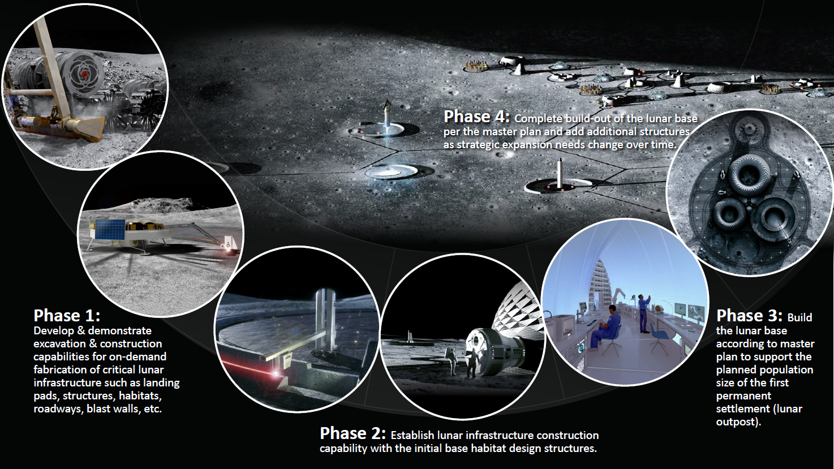

**Figure 15. Notional phased lunar construction capability development roadmap.**

1. **Summary**

The Space Technology Mission Directorate is developing technologies to support NASA’s Artemis Program, which was depicted graphically in Figure 1. The Lunar Surface Innovation Initiative is the primary thrust area for the development of technologies focused on establishing a sustainable presence on the lunar surface. The MMPACT project supports this initiative through the development of capabilities for infrastructure construction that will protect astronauts and equipment from the lunar environment using lunar regolith as the building material. To accomplish this challenging goal, MMPACT has partnered extensively with experts in multiple disciplines across other Government agencies, NASA Centers, industry, and academia. These partnerships include dual use applications having common key functional requirements for Earth-based commercial (ICON) and military (DoD) applications and for construction of lunar surface infrastructure. In addition, early architectural design concepts for landing pads and habitats were developed by SEArch+ and the Bjarke Ingels Group to inform engineering decisions on the construction hardware design and development. Based on prior experience and surveys of the state of the art for materials and processes suitable for lunar construction, MMPACT is evaluating multiple materials and processes. These materials and processes will be thoroughly tested in simulated lunar environmental conditions to ensure, to the extent possible that lunar environments can be simulated, that the materials and processes will achieve the goals for lunar surface construction. These capabilities will be developed and demonstrated through a systematic, building block approach utilizing CLPS landers on planned STMD lunar surface construction technology demonstration missions. These missions will culminate in the early 2030s with the qualification of construction systems which will then be ready for commercialization for the creation of future lunar surface infrastructure needs.

**Acknowledgments**

The SEArch+ team for Project Olympus was comprised of the following associates: Michael Morris, Rebeccah Pailes-Friedman, and Melodie Yashar, as well as the following collaborators: Waleed Elshanshoury, Mahsa Esfandabadi, David Gomez, Alexander Guzeev, Vittorio Netti, and Albert Rajkumar.

**References**

[1] Clinton, R. G., Jr., “NASA Additive Manufacturing Initiatives: In Space Manufacturing and Rocket Engines” Presented at the 68th International Astronautical Congress (IAC), Adelaide, Australia, 25-29 September 2017.

[2] Khoshnevis, B., Bodiford, M. P., Burks, K. H., Ethridge, E., Tucker, D., Kim, W., … & Fiske, M. R. (2005, January). Lunar contour crafting—a novel technique for ISRU-based habitat development. In 43rd AIAA Aerospace Sciences Meeting and Exhibit—Meeting Papers (pp. 7397-7409).

[3] Clinton Jr., R. G., “NASA’s In Space Manufacturing Initiative and Additive Manufacturing Development for Rocket Engine Space Flight Hardware,” 11th International Conference on Additive Manufacturing and 3D Printing, University of Nottingham, United Kingdom, July 13-14, 2016

[4] Werkheiser, N. J., Fiske, M. R., Edmunson, J. E., and Khoshnevis, B. Development of additive construction technologies for application to development of lunar/martian surface structures using in-situ materials. Composites and Advanced Materials Exposition 2015.

[5] Johnston, M. M., “Additive Construction with Mobile Emplacement”, MSFC Research and Technology Report 2016, NASA/TM-2017-219502, page 54.

[6] “Lunar In Situ Materials-Based Habitat Technology Development Efforts at NASA/MSFC,” M.R. Fiske, et al., Proceedings: 10th ASCE Aerospace Division International Conference on Engineering, Construction and Operation in Challenging Environments: Earth & Space 2006, League City, TX, March 5-8, 2006.

[7] Khoshnevis, B., Bodiford, M.P., Burks, K.B., Ethridge, E., Tucker, D., Kim, W., Toutanji, H., and Fiske, M.R. (2005). “Lunar contour crafting – A novel technique for ISRU-based habitat development.” Proceedings of the 43rd AIAA Aerospace Sciences Meeting and Exhibit, Paper AIAA-2005-0538, January.

[8] M.R. Fiske, J.E. Edmunson, J.C. Fikes, “The Disruptive Technology That is Additive Construction: System Development Lessons Learned for Terrestrial and Planetary Applications” AIAA SPACE and Astronautics Forum and Exposition, September 2018.

[9] M. Fiske, J. Edmunson, J. Fikes, M. Johnston, and M. Case, “3D Printing in Space: A New Paradigm for America’s Military,” The Military Engineer; Vol. 110, No. 715 (2018), pp 74-76.

[10] Lane, John E., Metzger, Philip T., Immer, Christopher D., and Li, Xiaoyi. “Lagrangian Trajectory Modeling of Lunar Dust Particles,” Earth & Space 2008, Long Beach, CA, Mar. 3, 2008.

[11] Susante, Paul J., and Metzger, Philip T. “Design Test, and Simulation of Lunar and Mars Landing Pad Soil Stabilization Built with In Situ Rock Utilization.” Earth and Space 2016, Orlando, FL, April 11-15, 2016.

[12] NASA. (2020). NASA’s Lunar Exploration Program Overview (Issue September). https://www.nasa.gov/sites/default/files/atoms/files/artemis_plan-20200921.pdf

[13] Petrov, Georgi I.; Inocente, Daniel; Haney, Max; Katz, Neil; Koop, Colin; Makaya, Advenit; Arnhof, Marlies; Lakk, Hanna; Cowley, Aidan; Haignere, Claudie; Messina, Piero; Sumini, Valentina; Hoffman, Jeffrey A. (2019 July). Moon Village Reference

[14] Masterplan and Habitat Design (ICES-2019-280). 49th International Conference on Environmental Systems (ICES), Boston, Massachusetts, USA, 7-11 July 2019. Lubbock Texas, USA: Texas Tech University.

[15] Campbell, A., et al, “LunarPAD – On the Development of a Unique ISRU-Based Planetary Landing Pad for Cratering and Dust Mitigation,” 2021 Sci-Tech Conference, Nashville, TN, January 2021.

Pg11

[16] A.W. Fliflet, M.T. Lombardi, S.H. Gold, D. Lewis III (retired), R.W. Bruce, and A.K. Kinkead, “On-Orbit Microwave Curing of Space Shuttle Repair Materials,” Report (2007), https://apps.dtic.mil/sti/pdfs/ADA518213.pdf

[17] R.P. Wilkerson et al, “Characterizing the effects of thermal profile and gas environment on the heat treatment of JSC-1A lunar simulant using combined thermogravimetry and mass spectroscopy,” LSSW Fundamental and Applied Lunar Surface Research in Physical Sciences, August 18–19, 2021.

[18] G. Voecks et al, “Understanding Pretreatment Processes of Lunar Simulant to Assist in Defining Material Characterization,” LSSW Fundamental and Applied Lunar Surface Research in Physical Sciences, August 18–19, 2021.

[19] D. Rickman et al, “Basis of Creating a Microwave-Based Construction System for the Moon,” 2021 Joint Planetary and Terrestrial Mining Sciences Symposium and Space Resources Roundtable, Jun 8-11, 2021.

[20] M.R. Effinger et al, “Microwave Sintering: Initial Scale-Up for Lunar Landing and Launch Pad Construction,” 2021 Joint Planetary and Terrestrial Mining Sciences Symposium and Space Resources Roundtable, Jun 8-11, 2021.

[21] H. Shulman et al, “Exploration of Scalable Methods to Fabricate Synthetic Lunar Minerals for Engineered Regolith Simulants,” LSSW Fundamental and Applied Lunar Surface Research in Physical Sciences, August 18–19, 2021.

[22] R.W. Bruce et al, “Preliminary Considerations for Microwave Consolidation/Sintering of Lunar Regolith Simulant,” 55th Annual Symposium – International Microwave Power Institute (IMPI), Jun 28th-Jul 1st, 2021.

[23] Courtesy of Dr. William Kaukler and Curtis Bahr, Jacobs, September 2021.

[24] Grande, Melanie L., Moses, Robert W., Cosgrove, Patrick A., Mueller, Robert P., Prater, Tracie J., and Blanchard, Alex, “Protecting Crew and Surface Systems with a Long-Duration Lunar Safe Haven,” ASCEND 2021, Las Vegas NV, November 8-10, 2021.

1. MMPACT Principal Investigator, Science and Technology Office, AIAA Fellow
2. MMPACT Project Manager and Geologist, Science and Technology Office, AIAA Senior Member
3. MMPACT Microwave Structure Construction Capability Element Manager, Science and Technology Office
4. MMPACT Olympus Element Manager, Science and Technology Office
5. CEO, ICON Technology Inc.
6. VP of Strategic R&D, MMPACT Project Manager, ICON Technology Inc.
7. Director of Building Design & Performance, ICON Technology Inc., Professional AIAA Member.
8. Partner/Principal Architect, SEArch+, Professional AIAA Member
9. Partner/Principal Architect, SEArch+

   10 Partner/Principal Industrial Designer, SEArch+